# 

**SECTION G5  
TEAM 7**

**SMART CONTRACT PRODUCT (SCP)**

**DEPLOYMENT PLAN**

**BUILD 1.0.0**

**MAJOR RELEASE**

**<21/02/2019>**

# 

**Table of Contents**

**Deployment Description** **2**

Purpose 2

Business Requirements 2

Functional Requirements 2

Non-Functional Requirements 3

Personnel Involved 3

Organization Chart 3

Before deployment 4

During Deployment 5

Post-Deployment 5

Configuration Management 6

Code Compilation to Executables 6

File links 6

OS build and configuration 7

Network configuration 7

Security configuration 8

Architectural Diagram 9

Hour-by-hour plan 9

Communication Plan 9

Contact Information of Key Appointment Holders 9

Contact Information of G5T7 10

Disaster arising from complaints 10

Disaster arising from server 13

Change Request 14

Deployment Process 16

Routine Procedure 17

User Training 18

Monitoring Tools 18

Security/Server Tools 19

Rollback 20

Criteria 20

Testing 20

Implementation testing 21

**Appendix** **23**

Approvals 23

Risk Management 23

Documentation 23

# Deployment Description

## Purpose

The purpose of the Deployment Plan is to describe the factors necessary for a smooth deployment and transition to operations. As such, the Deployment Plan covers tasks as required of the deployment of the Smart Contract Product (SCP) including preparation, installation, training, stabilization and monitoring for stability.

Subsequently, the Deployment Plan is constructed with the following considerations

* The team is to deploy, harden and monitor the image before it is launched
* The team is to employ a well-planned change process to redeploy a new image as soon as possible if changes are required by the client
* In any case of disaster, the team is to recover as quick and as efficient as possible
* The team would need to ensure that the server has zero downtime during launch week and 99.9% availability during other times
* The server must be able to support at least 50 concurrent users and maintenance can only be conducted on Sundays

## Business Requirements

|  |  |  |
| --- | --- | --- |
| **S/No** | **Performance Target** | **Metrics** |
| 1 | Zero downtime of corporate website during launch week | Duration of server not available |
| 2 | Three nines (99.9% availability) during other times | Duration of server not available |
| 3 | Smart Contract Product application deployed | Expected output displayed |

## 

## Functional Requirements

|  |  |  |
| --- | --- | --- |
| **S/N** | **Use-Case**  **(Smart Contract Management Module)** | **New/Existing/To Be Modified** |
| 1 | Create legally binding contracts | New |
| 2 | Execute legally binding contracts automatically | New |
| 3 | View embedded link page to a Google Presentation Slides | New |

## Non-Functional Requirements

|  |  |  |
| --- | --- | --- |
| **S/N** | **Non-Functional Requirements** | **Category** |
| 1 | Ability to handle handle about 428 connections per second | Reliability |
| 2 | Zero downtime of corporate website during launch week | Reliability |
| 3 | Three nines (99.9% availability) during other times | Reliability |
| 4 | Ability to support at least 50 concurrent users | Capacity |

## Personnel Involved

### Organization Chart

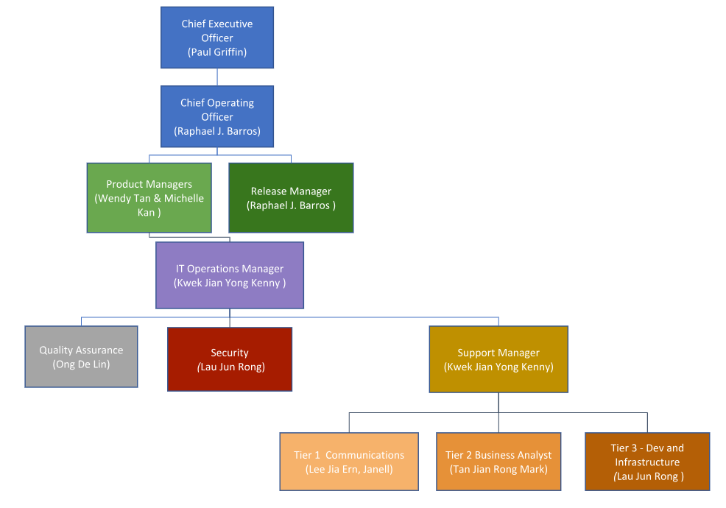

### 

### **Before deployment**

(Before 07/02/19 0000Hrs)

|  |  |  |  |
| --- | --- | --- | --- |
| **Name** | **Team** | **Role** | **Actions** |
| Kenny Kwek | Server | IT Operations Manager &  Support Manager | 1. Update Product Manager of hour-by-hour plan and obtain production image 2. Prepare Final Sign-off, progress log, hour-by-hour plan, ready-to-go checklist 3. Clarify with Product Manager & COO on any business and technical queries |
| Ong De Lin | Security | Quality Assurance | 1. Understand role and prepare for deployment 2. Configuration management 3. Participate in drafting progress log, hour-by-hour plan, ready-to-go checklist 4. Ensure that documents are prepared according to business requirements |
| Lee Jia Ern, Janell | Security | Tier 1 - Communication | 1. Understand role and prepare for deployment 2. Participate in drafting progress log, hour-by-hour plan, ready-to-go checklist |
| Tan Rong Jian Mark | Server | Tier 2 - Business Analyst | 1. Understand role and prepare for deployment 2. Participate in drafting progress log, hour-by-hour plan, ready-to-go checklist |
| Lau Jun Rong | Server | Tier 3 - Dev and Infrastructure &  Security | 1. Understand role and prepare for deployment 2. Participate in drafting progress log, hour-by-hour plan, ready-to-go checklist |

### 

### **During Deployment**

(07/02/19 0000Hrs to 20/02/19 2359Hrs)

|  |  |  |  |
| --- | --- | --- | --- |
| **Name** | **Team** | **Role** | **Actions** |
| Kenny Kwek | Server | IT Operations Manager &  Support Manager | 1. Construct Risk and Mitigation Plan 2. Communicate with team members to ensure smooth deployment |
| Ong De Lin | Security | Quality Assurance | 1. Setup initial hardening, automatic AMI backups and conduct implementation testing post-deployment 2. Inform team if conditions for full rollback are met |
| Lee Jia Ern, Janell | Security | Tier 1 - Communication | Setup initial monitoring |
| Tan Rong Jian Mark | Server | Tier 2 - Business Analyst | Create and deploy AWS instance with associated elastic IP address |
| Lau Jun Rong | Server | Tier 3 - Dev and Infrastructure &  Security | Setup extra hardening & load balancing |

### **Post-Deployment**

(After 20/02/19 0000Hrs)

|  |  |  |  |
| --- | --- | --- | --- |
| **Name** | **Team** | **Role** | **Actions** |
| Kenny Kwek | Server | IT Operations Manager &  Support Manager | 1. Update Product Manager of successful deployment 2. Prepare and sign Final Sign-off document 3. Manage IT enterprise solution management team 4. Liaise with Product Manager and COO on any issues faced |
| Ong De Lin | Security | Quality Assurance | 1. Ensure servers are live 24/7 2. Conduct smoke and full test (implementation testing) on Sundays 3. Ensure that documentations are managed properly |
| Lee Jia Ern, Janell | Security | Tier 1 - Communication | 1. Ensure servers are live 24/7 2. Assist users with any issues faced |
| Tan Rong Jian Mark | Server | Tier 2 - Business Analyst | 1. Ensure servers are live 24/7 2. Investigate any issues which could not be solved by Tier 1 |
| Lau Jun Rong | Server | Tier 3 - Dev and Infrastructure &  Security | 1. Troubleshoot and resolve any issues discovered by Tier 2 2. Ensure servers are secured |

## Configuration Management

### **Code Compilation to Executables**

|  |  |  |
| --- | --- | --- |
| **Name of Component** | **Remarks** | **Date Deployed** |
| createAMI.js script | - | 13 February 2019 |
| deleteAMI.js script | - | 13 February 2019 |
| roles.json script | - | 13 February 2019 |

### **File links**

|  |  |  |
| --- | --- | --- |
| **Name of Component** | **Remarks** | **Date Deployed** |
| Github | [Github Url to access official documentations](https://github.com/delinhquentz/G5T7-SCP) | 7 February 2019 |
| Deployment Description | - | 21 February 2019 |
| Hour-by-Hour Plans | - | 17 February 2019 |
| Progress Logs | - | 7 February 2019 |
| Ready-to-Go Checklists | - | 7 February 2019 |
| Risk Descriptions | - | 16 February 2019 |
| Final Sign-Off Documents | - | 15 February 2019 |
| Approval Documents | - | 15 February 2019 |
| Deploying SSL Certificate Documentation | - | 16 February 2019 |
| Automated AMI Backup Documentation | - | 14 February 2019 |
| Deploying Django Application using Gunicorn | - | 17 February 2019 |
| Hardening the Nginx server (Configuration file) Documentation | - | 17 February 2019 |

### **OS build and configuration**

|  |  |  |
| --- | --- | --- |
| **Name of Component** | **Remarks** | **Date Deployed** |
| Smart Contract Product | **Build:** SCP 1.0.0  **Deployed ports:** 8000(default), 8001(gunicorn) | 7 February 2019 |
| Django framework | **Version:** 2.1.5 | 7 February 2019 |
| Amazon Linux (variant from Red Hat/CentOS) | Linux Kernel 4.14. | 7 February 2019 |
| Python | Version 3.6  Pip 9.0.3 | 7 February 2019 |
| Cloudwatch Event Rules for AMI | - | 13 February 2019 |
| Lambda Functions (to create and delete AMI) | - | 13 February 2019 |
| IAM Role | - | 13 February 2019 |

### **Network configuration**

|  |  |  |
| --- | --- | --- |
| **Name of Component** | **Remarks** | **Date Deployed** |
| Cloudtopus | - | - |
| Nginx | **Version:** 1.14.1 | 7 February 2019 |
| puTTy | **Version:** 0.63 | - |
| FileZilla | **Version:** 3.40.0 | - |
| Nginx | **Version:** 1.14.1 | 7 February 2019 |
| AWS Instance | T2.Micro, 1 vCPU, 1 GB RAM, 10 GB Storage | 7 February 2019 |
| Elastic IP Address | 3.1.118.42 | 7 February 2019 |
| htop | **Version:** 1.0.1 | 7 February 2019 |
| AWS Alarms | - | 7 February 2019 |
| AWS CloudWatch | - | 7 February 2019 |
| Domain Name | [www.esmscp.tk](http://www.esmscp.tk) and [esmscp.tk](http://esmscp.tk) | 13 February 2019 |
| Gunicorn | **Version:** 19.9.0 | 17 February 2019 |
| Siege | **Version:** 4.0.2 | 17 February 2019 |

### **Security configuration**

|  |  |  |
| --- | --- | --- |
| **Name of Component** | **Remarks** | **Date Deployed** |
| AWS Security group | HTTP Port 80, SSH Port 22, Custom TCP Rule Port 8000 - 8999 & HTTPS Port 443 | 7 February 2019 |
| Public & Private key | - | 7 February 2019 |
| Certbot | **Version:**0.32.0 | 13 February 2019 |
| SSL Certificate | **Serial Number:** 03a5d271865d20dbfa01f74676c7f57b3d31 **Key:**  RSA 2048 bits(e 65537) **Issuer:**  Let’s Encrypt Authority X3 **Signature Algorithm:** SHA256withRSA  **Valid from:**  Wed, 13 Feb 2019  **Valid till:**  Tue, 14 May 2019  **Protocols:**  TLS1.0, TLS1.1 | 13 February 2019 |

## Architectural Diagram

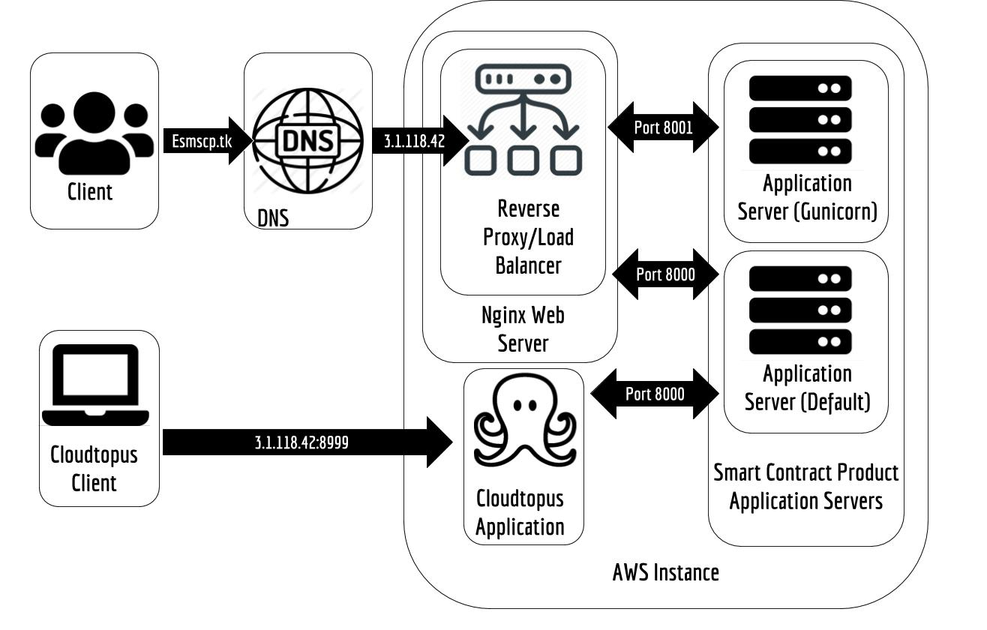

## Hour-by-hour plan

|  |  |  |  |
| --- | --- | --- | --- |
| **Hour-by-Hour Plan** | **Ready-to-Go Checklist** | **Progress Log** | **Final Sign-Off** |
| [SCP Build 1.0.0](https://docs.google.com/spreadsheets/d/1aFfyFRKEZFd8qp4SUgmKEcXTwInqIk5T_Yyf77jbgAQ/edit#gid=839546569) | [SCP Build 1.0.0](https://docs.google.com/spreadsheets/d/1O3x0tNz4qmLb2ZuZOsJibo7pg90QV9OIzA6m1VjsjtU/edit) | [SCP Build 1.0.0](https://docs.google.com/spreadsheets/d/16WHHnU0ZnQ4rXRMpfILa_6Tnmke2Ham0XVOl62h8K98/edit#gid=0) | [SCP Build 1.0.0](https://docs.google.com/document/d/1QUqwQL-EW5ZId2Fa1DeniYiwSwk_piS3QIDhJK_E1Gc/edit) |

## Communication Plan

### **Contact Information of Key Appointment Holders**

|  |  |  |
| --- | --- | --- |
| **Name** | **Role** | **Contact** |
| Paul Griffin | Chief Executive Officer | [paulgriffin@smu.edu.sg](mailto:paulgriffin@smu.edu.sg) / 6828 9587 |
| Rafael J. Barros | Chief Operating Officer / Release Manager | [rafaelbarros@smu.edu.sg](mailto:rafaelbarros@smu.edu.sg) / 6828 9675 |
| Wendy Tan | Product Manager | [wendytanlc@smu.edu.sg](mailto:wendytanlc@smu.edu.sg) / 6828 1967 |
| Michelle Kan | Product Manager | [michellekan@smu.edu.sg](mailto:michellekan@smu.edu.sg) / 6828 9094 |

### **Contact Information of G5T7**

|  |  |  |
| --- | --- | --- |
| **Name** | **Role** | **Contact** |
| Kenny Kwek | IT Operations Manager &  Support Manager | [kenny.kwek.2017@sis.smu.edu.sg](mailto:kenny.kwek.2017@sis.smu.edu.sg) / 9620 1737 |
| Ong De Lin | Quality Assurance | [delin.ong.2017@sis.smu.edu.sg](mailto:delin.ong.2017@sis.smu.edu.sg) / 8168 9456 |
| Lee Jia Ern, Janell | Tier 1 - Communication | [janell.lee.2017@sis.smu.edu.sg](mailto:janell.lee.2017@sis.smu.edu.sg) / 8285 7148 |
| Lau Jun Rong | Tier 2 - Business Analyst | [mark.tan.2017@sis.smu.edu.sg](mailto:mark.tan.2017@sis.smu.edu.sg) / 8405 7248 |
| Tan Rong Jian Mark | Tier 3 - Dev and Infrastructure & Security | [junrong.lau.2017@sis.smu.edu.sg](mailto:junrong.lau.2017@sis.smu.edu.sg) / 9297 1479 |

### **Disaster** Arising from Complaints

|  |  |  |  |  |
| --- | --- | --- | --- | --- |
| **From** | **To** | **When** | **Content** | **How** |
| Web users & Business Stakeholders | Tier 1 | Unable to access SCP services | Access duration, timeline of events, actions taken | Email / Phone |
| Tier 1 | Web users & Business Stakeholders | After Tier 1 understand web users’ & business stakeholders’ situation | Analyze situation and recommend possible steps to rectify situation | Phone |
| Tier 1 | Quality Assurance | Web users & Business Stakeholders unable to access SCP services | Timeline of event, web users’ and business stakeholders’ situation, actions taken, current status, suspected root cause, suspected actions to take, analysis of situation | Phone / Telegram |
| Tier 1 | Quality Assurance | After Web users & Business Stakeholders has solved their issues | Actions taken, current status, root cause, systems affected | Phone / Telegram |
| Quality Assurance | IT Operations & Support Manager | After conducting tests on affected system | Status of system | Phone / Telegram |
| Tier 1 | Tier 2 | Unable to resolve issues from web users & business stakeholders | Preliminary investigation, current SCP status, suspected root cause, suspected actions to take, actions taken | Phone /Slack/Telegram |
| Tier 2 | Tier 1 | After understanding web users’ & business stakeholders’ situation from Tier 1 | Analyze situation and recommend possible steps to rectify situation | Phone / Slack/Telegram |
| Tier 2 | Tier 3 | After understanding web users’ & business stakeholders’ situation from Tier 1 | Analyze situation and recommend possible steps to rectify situation | Phone /Slack/Telegram |
| Tier 3 | Tier 1 | After understanding web users’ & business stakeholders’ situation from Tier 2 | Have made rectification actions to server, final update of situation, provide necessary steps for users to take | Phone / Slack/ Telegram |
| Tier 3 | Tier 1 | Unable to resolve web users’ and business stakeholders’ situation after making rectification actions to server | Current status, suspected root cause, questions to prompt the user/stakeholder | Phone/Slack/Telegram |
| Tier 3 | Tier 2 | After understanding web users’ & business stakeholders’ situation from Tier 2 | Have made rectification actions to server, update of situation, | Phone / Slack/ Telegram |
| Tier 3 | Support & IT Operations Manager | Unable to resolve web users’ and business stakeholders’ situation after making rectification actions to server | Timeline of event, web users’ and business stakeholders’ situation, actions taken, current status, suspected root cause, suspected actions to take | Phone / Telegram |
| Support & IT Operations Manager | COO | After receiving updates from Tier 3 of web users’ and business stakeholders’ situation | Timeline of event, web users’ and business stakeholders’ situation, actions taken, current status, suspected root cause, suspected actions to take, analysis of situation | Phone / Telegram |
| Support & IT Operations Manager | CEO / COO | After receiving updates from Tier 3 of web users’ and business stakeholders’ situation and has negative impact on business | Timeline of event, web users’ and business stakeholders’ situation, actions taken, current status, suspected root cause, suspected actions to take, analysis of situation, negative impact on business | Phone / Telegram |

Process Workflow Diagram can be found in the appendix.

### 

### Disaster Arising from Server Issues

|  |  |  |  |  |
| --- | --- | --- | --- | --- |
| **From** | **To** | **When** | **Content** | **How** |
| Tier 1 / Tier 2 / Quality Assurance | Tier 3, IT Operations Manager & Support Manager | Server is down and not running | Estimated time started, duration | Phone/ Telegram |
| Tier 1 / Tier 2 / Quality Assurance | Tier 3, IT Operations Manager & Support Manager | Unusual activity with server | CPU Utilization Average, Network In/Out Average, Network Packets In/Out Average, Status Check Failed, Sum/Instance/System Sum, peaks, processes | Phone/ Telegram |
| Tier 1 / Quality Assurance | Tier 3, Security, IT Operations Manager & Support Manager | Website does not show expected output | Output that the website is showing | Phone/ Telegram |
| Tier 3 & Security | Quality Assurance, IT Operations Manager & Support Manager | After rectifications are made | Changes to server and security are made to solve expected output | Phone / Telegram |
| Quality Assurance | Tier 3, Security, IT Operations Manager & Support Manager | After testing is completed | Changes to server and security are correct | Phone / Telegram |
| IT Operations Manager & Support Manager | COO | After receiving updates that there are issues with server | Timeline of event,actions taken, current status, suspected root cause, suspected actions to take, analysis of situation | Phone / Telegram |
| IT Operations Manager & Support Manager | CEO / COO | After receiving updates that there are issues with server and has negative impact on business | Timeline of event,actions taken, current status, suspected root cause, suspected actions to take, analysis of situation, negative impact on business | Phone / Telegram |

### **Change Re**quest

|  |  |  |  |  |
| --- | --- | --- | --- | --- |
| **From** | **To** | **When** | **Content** | **How** |
| Web users & Business Stakeholders | COO | Addition of new functions required due to business requirements | Details of specific function and non-functional requirements | Email/ Phone |
| COO | Product Manager & Release Manager | Addition of new functions required due to business requirements | Details of specific function and non-functional requirements | Email/ Phone |
| Release Manager | Product Manager | Build is ready for released and requires approval for release | Details of specific function and non-functional requirements | Email/ Phone |
| Product Manager | Release Manager, Support & IT Operations Manager | Approves release of new build | Details of specific function and non-functional requirements | Email/ Phone |
| Support & IT Operations Manager | CEO / COO | Major version release | Deployment Description, Process Log, Hour-by-Hour Plan, Ready-to-Go Checklist | Email |
| Tier 3 | Support & IT Operations Manager | Minor version release / Revision version release | Changelog in Deployment Description, Process Log, Hour-by-Hour Plan, Ready-to-Go Checklist | Email |
| Support & IT Operations Manager | COO / Product Manager | Preparation for deployment completed | Approval for deployment | Email |
| COO / Product Manager | Support & IT Operations Manager | Preparation for deployment completed and deployment is approved | Deployment preparation approved and ready for deployment | Email |
| Tier 3 | Support & IT Operations Manager | Bug fixes | Changelog and bug report | Email / Phone |
| Security | Support & IT Operations Manager | Replacement of SSL Certificate when nearing expiration | Inform details regarding the SSL replacement and resources to retrieve the new SSL certificate | Email |
| COO | Support & IT Operations Manager | Domain Change Request | Details of domain change | Email |
| Support & IT Operations Manager | Tier 3 | Domain Change Request | Details of domain change | Email |
| IT Operations Manager | COO | Change in IT support team’s role assignment | Details of change in role assignment: Names, role changed as well as reason for doing do. | Email |
| Support & IT Operations Manager | COO | Addition of new software tool | Details of new software tools, user guide of new software tools | email |
| Tier 3 & Security | Quality Assurance, Support & IT Operations Manager | Changes to server and security has been made | Details of changes | Phone/ Telegram |
| Quality Assurance | Tier 3, Security, Support & IT Operations Manager | Changes to server and security has been tested | Status of changes | Phone / Telegram |

### **Deployment Process**

|  |  |  |  |  |
| --- | --- | --- | --- | --- |
| **From** | **To** | **When** | **Content** | **How** |
| IT Operations & Support Manager | COO, Product Manager | As soon as deployment is completed and is tested successfully | Success or rollback  Any remaining issues | Email |
| IT Operations & Support Manager | CEO, COO, Product Manager | When there are unexpected business impact-related issues faced during deployment | Issues that has potential impact on the business or customers | Email, Meeting, Phone / Telegram |
| IT Operations & Support Manager | COO, Product Manager | When there are unexpected technical-related issues faced during deployment | Issues faced, possible rectification actions & progress of solving issue, task list with status, provide a timeline of events | Email / Phone / Telegram |
| Tier 1 | Web users & Business Stakeholders | Before deployment | Estimated Duration of deployment, any new relevant features that the users would want to know during this deployment | Email, Social Media, Newsletter |
| IT Operations & Support Manager | COO, Product Manager | When rollback criteria met | Issues faced, rollback criteria met, task list with status, provide a timeline of events | Phone / Telegram |
| Tier 1,2,3, Security | IT Operations & Support Manager | When any issues are faced during deployment | Issues faced, extend of issues, attempts to rectify issues, suggestions on next course of actions | Phone / Telegram |
| Tier 1,2,3, Security, Quality Assurance | Quality Assurance/ IT Operations & Support Manager | After completing tasks on Hour-by-Hour plan | Verify that tasks are completed correctly and successfully | Phone / Telegram |
| COO | Product Manager & Release Manager | Business stakeholders want to release new product | Details of specific function and non-functional requirements | Email/ Phone |
| Release Manager | Product Manager | Build is ready for released and requires approval for release | Details of specific function and non-functional requirements | Email/ Phone |
| Product Manager | Release Manager, Support & IT Operations Manager | Approves release of new build | Details of specific function and non-functional requirements | Email/ Phone |
| Support & IT Operations Manager | COO / Product Manager | Release of new build is ready and preparation for deployment completed | Deployment Description, Process Log, Hour-by-Hour Plan, Ready-to-Go Checklist, Approval for deployment | Email |
| COO / Product Manager | Support & IT Operations Manager | Release of new build is ready, preparation for deployment completed and deployment is approved | Deployment preparation approved and ready for deployment | Email |

### Routine Procedure

|  |  |  |  |  |
| --- | --- | --- | --- | --- |
| **From** | **To** | **When** | **Content** | **How** |
| IT Operations & Support Manager | COO, Product Manager | Team wants to conduct maintenance and testing on Sundays | Ask for approval 2 working days before maintenance and testing | Email |
| Tier 1 | Web users & Business Stakeholders | After receiving approval for maintenance and testing | Estimated duration of maintenance | Email, Social Media, Newsletter |
| IT Operations & Support Manager | COO, Product Manager | After team has conducted maintenance and testing successfully | Inform status of server, issues faced and rectification steps taken to resolve them. | Email |
| IT Operations & Support Manager | COO, Product Manager | When there are unexpected technical-related issues faced during maintenance and testing | Issues faced, possible rectification actions & progress of solving issue, task list with status, provide a timeline of events | Email / Phone / Telegram |
| IT Operations & Support Manager | COO, Product Manager | When rollback criteria met during maintenance and testing | Issues faced, rollback criteria met, task list with status, provide a timeline of events | Phone / Telegram |
| Quality Assurance | IT Operations & Support Manager | When any issues are faced during maintenance and testing | Issues faced, extend of issues, attempts to rectify issues, suggestions on next course of actions | Phone / Telegram |
| IT Operations & Support Manager | COO | Every week | Identify risks, top 3 risks of the week and their respective mitigation strategy | Email |

## User Training

### Monitoring Tools

|  |  |  |
| --- | --- | --- |
| **IT Systems** | **Role** | **Training Required** |
| Cloudwatch dashboard | 1. IT Operations Manager 2. Support Manager 3. Quality Assurance 4. Tier 1 - Communication 5. Tier 2 - Business Analyst | 1. Knowledge and understanding of monitoring charts such as CPU Utilization Average, Network In/Out Average, Network Packets In/Out Average, Status Check Failed Sum/Instance/System Sum. 2. Ability to identify peaks. |
| Cloudwatch alarms | 1. IT Operations Manager 2. Support Manager 3. Quality Assurance 4. Tier 1 - Communication 5. Tier 2 - Business Analyst | Understanding of alarm creation and alarm settings |
| Cloudtopus | 1. IT Operations Manager 2. Support Manager 3. Quality Assurance 4. Tier 1 - Communication 5. Tier 2 - Business Analyst | 1. Knowledge and understanding of monitoring charts such as CPU Usage and Network Packets in tracking. 2. Ability to identify peaks. |
| htop | 1. IT Operations Manager 2. Support Manager 3. Quality Assurance 4. Tier 1 - Communication 5. Tier 2 - Business Analyst | 1. Understanding of Bash Linux command line. 2. Understanding to read processes information and identify peak processes. 3. Understand how to know that server is up and running |

### Security/Server Tools

|  |  |  |
| --- | --- | --- |
| **IT Systems** | **Role** | **Training Required** |
| Amazon Linux | 1. Tier 3 - Dev and Infrastructure 2. Security | Understand Bash Linux command line |
| NGINX server | 1. Tier 3 - Dev and Infrastructure 2. Security | Set up of NGINX server and configuration of native load balancer |
| SSL certificate | 1. Tier 3 - Dev and Infrastructure 2. Security | Understand SSL Protocols |
| AMI Snapshot Backup | 1. Tier 3 - Dev and Infrastructure 2. Security | Understand required AMI Snapshot Backup procedures |
| Gunicorn | 1. Tier 3 - Dev and Infrastructure 2. Security | 1. Installation of Gunicorn 2. Gunicorn Configuration 3. Deploying using Gunicorn |
| Siege | 1. Tier 3 - Dev and Infrastructure 2. Security 3. Quality Assurance | Understand functionalities of Siege and how to operate them |

## 

## Rollback

### Criteria

|  |  |
| --- | --- |
| **Criteria**  **(any)** | 1. When any of the critical business functions are not working during testing after deployment or changes. 2. When any of the configuration files are not set up properly 3. If issues cannot be fixed by 10am the next day |
| **Action** | Perform a full rollback:   1. Seek approval from COO & Product Manager to rollback 2. Obtain written approval 3. Stop instance 4. Detach current volume 5. Attach latest working AMI as current volume 6. Restart instance 7. Test that the application is working correctly 8. IT Manager & COO signs off for post-rollback testing |

### Testing

Ensure that:

1. Landing page is visible <http://www.esmscp.tk/>
2. Landing page has ssl certificate <https://www.esmscp.tk/>
3. htop is installed
4. Nginx server has started
5. Security group has the necessary inbound rules *(HTTP Port 80, SSH Port 22, Custom TCP Rule Port 8000 - 8999 & HTTPS Port 443)*
6. Tags for AWS instance, *‘Backup = yes, BackupNoReboot = true, BackupRetentionDays = 1’* has been created for automated AMI backup
7. The certificate ranking is valid
8. Cloudtopus is able to monitor status of application
9. AWS Alarms are set
10. The server can handle 50 concurrent requests

## 

## Implementation testing

|  |  |
| --- | --- |
| **Test Case** | **Results** |
| Successful linking of domain name to elastic IP   1. Visit <http://www.esmscp.tk/> 2. Ensure that SCP’s front page loads successfully | Landing page is visible <http://www.esmscp.tk/> |
| Successful installation of SSL Certificate   1. Visit <https://www.esmscp.tk/> 2. Click on lock icon beside web address 3. Verify that “Connection is secure” is shown in the pop-up | Landing page has SSL Certificate <https://www.esmscp.tk/> |
| Successful installation of htop   1. Access SSH terminal 2. Type “htop --version” 3. Verify that command outputs “htop 1.0.1” to confirm that htop is installed | htop is installed |
| Nginx Server works correctly   1. Access SSH terminal 2. Type “service nginx status” 3. Verify that command outputs “nginx (pid 27083) is running…” to confirm Nginx server has started | Nginx server has started |
| Correct security group settings   1. Visit AWS and login to project account “[mark.tan.2017@smu.edu.sg](mailto:mark.tan.2017@smu.edu.sg)” 2. Click on Security Groups under Network and Security 3. Select group with Group Name of “launch-wizard-1” 4. Click on the inbound tab at the bottom of the screen 5. Visually confirm that security group is correct | Security group has the necessary inbound rules *(HTTP Port 80, SSH Port 22, Custom TCP Rule Port 8000 - 8999 & HTTPS Port 443)* |
| Correct Tags   1. Visit AWS and login to project account “[mark.tan.2017@smu.edu.sg](mailto:mark.tan.2017@smu.edu.sg)” 2. Click on Services > EC2 > Running Instance 3. Select on SCP instance > tags > check that the tags are created | Tags for AWS instance, ‘*Backup = yes, BackupNoReboot = true, BackupRetentionDays = 1*’ has been created for automated AMI backup |
| Valid SSL Certificate   1. Visit <https://www.ssllabs.com/ssltest/> and enter ‘esmscp.tk’ then submit 2. Wait for the test to finish running | The certificate ranking is valid |
| Successful linking Cloudtopus to AWS instance   1. Visit [https:/www.cloudtopus.com](http://www.cloudtopus.com) and login with SMU Google Account 2. Click on the “Monitor” tab at the front page 3. Verify that Parent Server Status is “Live” 4. Verify that WebApp Status is “Live” | Cloudtopus is able to monitor status of application. |
| Successful setting of AWS Alarms   1. Visit AWS and login to project account “[mark.tan.2017@smu.edu.sg](mailto:mark.tan.2017@smu.edu.sg)” 2. Click on Services > Cloudwatch under Management & Governance 3. Verify that alarms are set on dashboard | Able to affirm that the relevant AWS Alarms have been set and are in operation, by viewing the “Monitoring” panel in the particular instance. |
| The server can handle 50 concurrent requests   1. Check that siege is installed on lab account’s instance 2. SSH into lab account’s instance 3. Type ‘siege esmscp.tk -c 50’ for 50 users. 4. After 5 to 10 minutes, press Ctrl + C to terminate and see summary. | The server is able to handle the requests with 100% uptime for 50 users. |

# Appendix

## Approvals

1. [**Approval for deploying SCP Build 1.0.0**](https://docs.google.com/document/d/1TzHA6uEHnkkvHnCcgoIxMRBSPkghlV8lZ6R-gXa2Z2I/edit?usp=sharing)
2. [**Approval for Gunicorn**](https://docs.google.com/document/d/1RQvDIT8MkUjqw5QqOZQ5O4hWQeQBBfe-hArvAoWZXn0/edit?usp=sharing)
3. [**Approval for Automated AMI Backup**](https://docs.google.com/document/d/1K0_fthJrudteOY7i4z1vGbhfvpktANs6R9gJOg71gPo/edit)

## Risk Management

1. [**Week 6**](https://docs.google.com/document/u/1/d/1M6mmypZDuUBjAQm7d1Rx0mFN6WlrlvSTaSjb8GfltHQ/edit?usp=drive_web&ouid=113467154525055047448)
2. [**Week 7**](https://docs.google.com/document/d/1HPib6bjF6FID17Q49Gt_SJOJIb1tZfaOCwUKMABdaTs/edit)

## Documentation

1. [**Deploying Django Application using Gunicorn**](https://docs.google.com/document/d/1Wdn_n-wPPJLnVgRQJOGil6Zk8MTKOSvT12uelKwAhLk/edit)
2. [**Deploying SSL Certificate Documentation**](https://docs.google.com/document/d/1-3d0dBoc8XVgycPo9MP7aFrn7juQyik-uw1B8pnRPo0/edit)
3. [**Hardening the Nginx server (Configuration file)**](https://docs.google.com/document/d/15s7GhfChsnZbQUjrb9fhy_ZLeQ3G9vzZBb3aKC3lh64/edit)

## Process Workflow Diagram for Disaster Recovery

1. [**Disaster Arising From Complaints**](https://drive.google.com/open?id=1EF_ObJi-T3vGNk0QQFt8ENzVZyVyl8go)